9.1.1 VOWELS IN A STRING
ALGORITHM
- Start
- Input string s
- Initialize count = 0
- For each character in string
- Check if character is vowel
- If yes, increment count
- Print count
- End
FLOWCHART
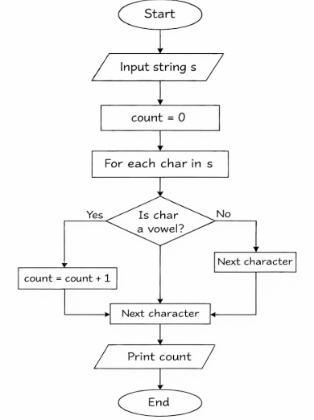

PROGRAM
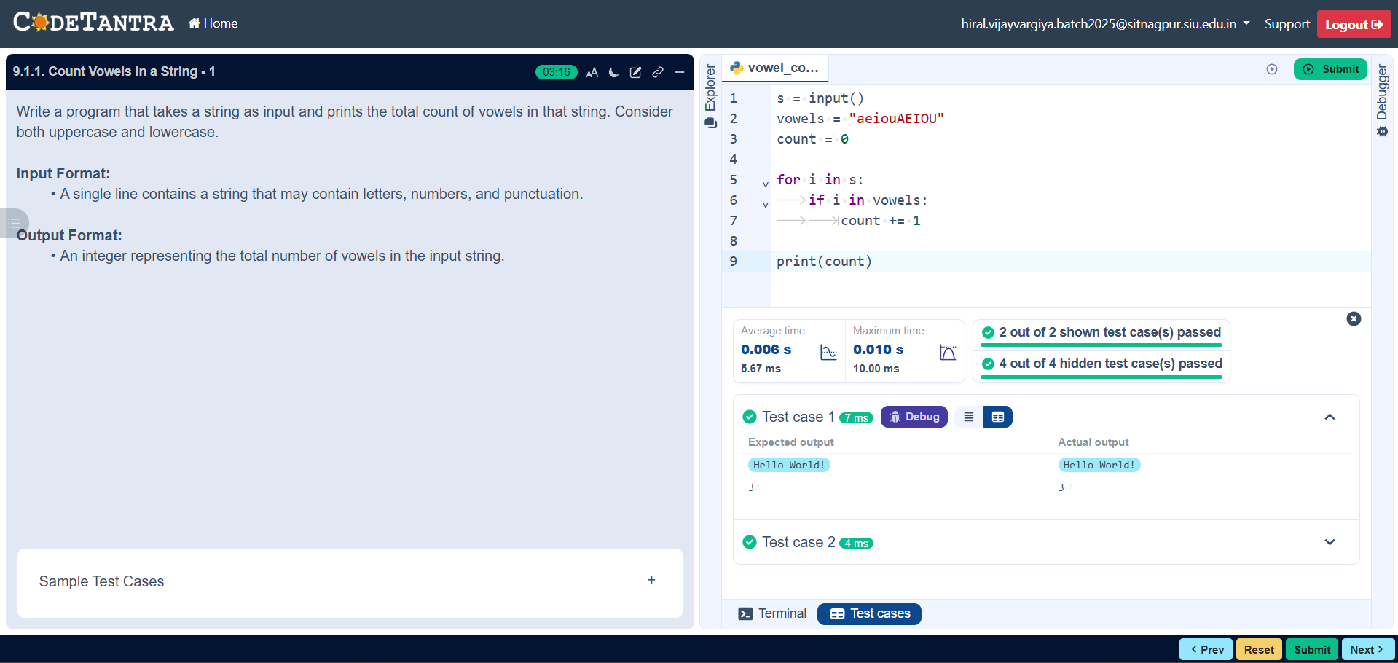

9.1.2 PALINDROME OR NOT
ALGORITHM
- Start
- Input string s
- Reverse the string → rev = s[::-1]
- Compare s with rev
- If equal → Print "Palindrome"
- Else → Print "Not a Palindrome"
- End
FLOWCHART
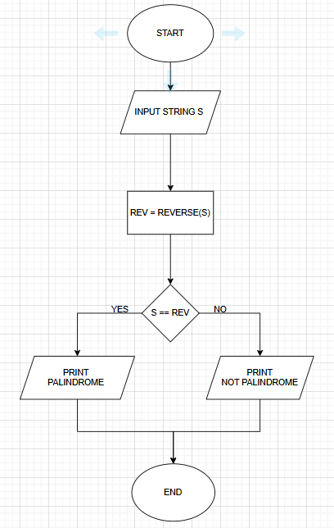
PROGRAM
